FOR IMMEDIATE RELEASE
Groundbreaking Ceremony Held for Laramie Rotary Clubs Park at Grand View Heights

Laramie, WY – August 22, 2024 – The City of Laramie, in partnership with the Rotary Club of Laramie and Laramie Sunrise Rotary Club, celebrated the official groundbreaking of the Laramie Rotary Clubs Park at Grand View Heights this morning. The event, held at 9:00 AM, marked a significant milestone in the development of a much-anticipated community space in the Grand View Heights neighborhood.
The groundbreaking ceremony was attended by an array of community leaders and stakeholders, including City Council Members, representatives from both Rotary Clubs, City of Laramie and Laramie Parks and Recreation staff, and a representative from Big Huhnks Excavation Inc., the contractor selected for the project.
Randi Downham, former President of the Rotary Club of Laramie, and Larry Struempf, President of Laramie Sunrise Rotary, both spoke about the importance of the project to the Rotary Clubs and the broader community. “We’re thrilled to see the hard work and collaboration between the City, the Rotary Clubs, and our community partners come to fruition,” remarked Struempf during his speech at the ceremony. Downham added, “This park has been a long time coming, and it’s a great day for the residents of Grand View Heights.”
The park, named in recognition of the Laramie Rotary Clubs' significant contributions to its planning and design, will feature a range of amenities including playground equipment, a shelter, a plaza, a dog park, site improvements, a restroom, and green space. Additionally, a crosswalk will be installed on Bill Nye Avenue to ensure safe access for residents and visitors.
Construction of the park has just begun, with Big Huhnks Excavation Inc. leading the project. The $1.65 million development is being funded through a combination of the Special Purpose Tax 2018 Fund, a federal Land and Water Conservation Fund (LWCF) grant, and park-in-lieu fees from local development.
Among the attendees was Rylan Lange, a young resident of the Grand View Heights neighborhood, who expressed his excitement about the new park. “I’m really looking forward to the playground equipment and having a park in my neighborhood,” Rylan said, capturing the enthusiasm shared by many local families.
The new park is expected to be a vibrant gathering space for the community, providing much-needed recreational opportunities for residents of all ages. The City of Laramie and the Laramie Rotary Clubs look forward to the continued development of the park and the positive impact it will have on the Grand View Heights neighborhood.
For more information on the Laramie Rotary Clubs Park and to stay updated on the project’s progress, please visit https://cityoflaramie.org/1191/Laramie-Rotary-Clubs-Park.
###

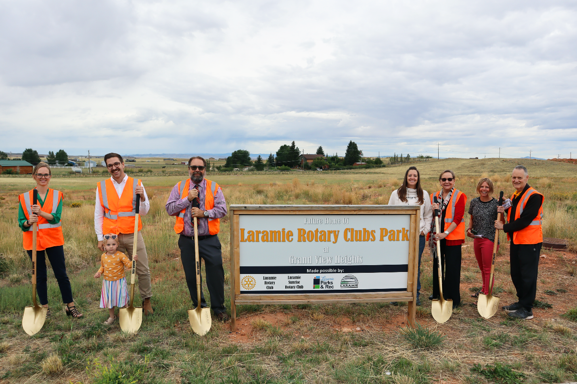
Left to right: Randi Downham, former President of the Rotary Club of Laramie; Brian Harrington and daughter, Mayor of the City of Laramie City Council; Dr. Larry Struempf, President of the Sunrise Rotary Club; Tara Smith, Big Huhnks Excavation; Sharon Cumbie, City of Laramie City Council Vice-Mayor; Micah Richardson, City of Laramie City Councilor; Pat Gabriel, City of Laramie City Councilor

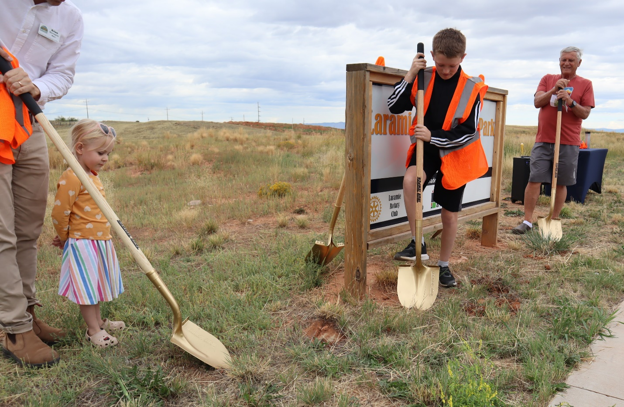
Ruby Harrington and Rylan Lange help break ground at the Groundbreaking Ceremony for the new Rotary Clubs Park in Grand View Heights

